Fairview Glen

Montessori

School

April 25, 2018 SCHOOL CALENDAR LINK: http://fairviewglen.com/newsletter/
International Day
Prepare to be captivated by culture as you tour classrooms and enjoy our students research and musical presentations between 9:00-11:30 a.m. All classes will perform in the gym, except Casa T will be in their classroom.
Performance Times:
Casa T 9:00 a.m. Canada
Lower El 9:20 a.m. Spain
Casa B 9:40 a.m. Costa Rica
Casa A 10:00 a.m. Philippines
Casa C 10:20 a.m. Dubai UAE
Upper El 11:00 a.m. Croatia
You are sure to enjoy this festive event!
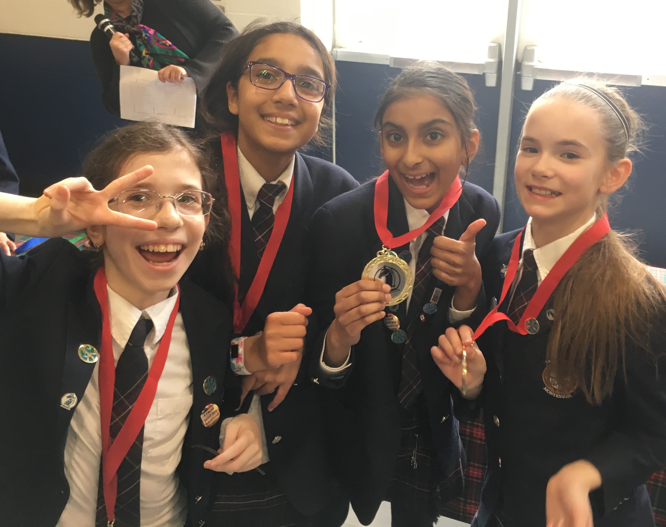
Chess Teams take a Gold, Silver & Bronze
“Our care of children should be governed, not by the desire to make them learn things, but by the endeavor always to keep burning within them that light which is called intelligence.” - Maria Montessori

Alberta Trip
Upper Elementary students depart for Alberta on Monday, April 30th. Please refer to your trip itinerary for details and stay tuned to Upper El’s Homeroom app. for our updates.

Casa Field Trip
Casa A, B, C will travel to RBG on May 1st for their “Bird Bonanza.” Bus departs at 9:00 a.m. and students are to wear their gym uniform with weather-suitable outer wear. Permission form attached

TEA WITH MOM
Thursday, May 10th is our annual, formal tea party, hosted in honour of our dear Mothers. Toddler, Casa, and Elementary Moms are invited. Please see the attached invitation.

JUMP ROPE FOR HEART
Heart & Stroke Foundation fundraising is about to begin and our Jump Date is May 17th. Please register your child at jumpropeforheart.ca.and begin your fundraising online. Our school fundraising goal is $3500.00. Your child can look forward to our Demo Day, May 10th, to kick off the program, and more information will be sent home that day. Parents of Casa & El. students are welcome to volunteer during the Jump times (El. 2:00-3:00 p.m. Casa 3-3:30 p.m.) on May 17th. Hope to see you there!

Chess Team
Congratulations to the Junior & Novice chess teams on their excellent standings in their recent tournament. Junior Girls took home the gold medal! In the Novice pool, our girls team won the silver medal and the boys team received the bronze medal. Thank you to Mr. Sage and Mrs. Volpe for an amazing season of Chess Club.
“In the Spring, I have counted 136 different kinds of weather
inside of 24 hours.” -Mark Twain

uniforms
Students are welcome to begin wearing skorts, shorts and golf shirts on days that are predicted to reach 15 degrees C. Please keep in mind that temperatures are fluctuating rapidly and make sure your child is prepared with appropriate outerwear to be outside throughout the day.
On another note, please send in your gently used uniforms so that we can continue to have new inventory for our sale. This sale is a huge help to our school families and an excellent way to support our Uganda project

Uganda project

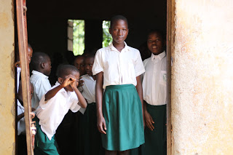
This past March, Fairview Glen Montessori’s Board of Directors met with SOS Children’s Villages to establish our Partnership and plan our future endeavours in Uganda. In addition to establishing family networks for orphans, SOS funds educational programs for citizens through their Family Strengthening Programs.
We thank all families for the commitment they have made for the upcoming school year to support SOS.

The need for quality Early Childhood programs is immense and we are very excited to begin our efforts with the construction of two schools and the establishment of an Early Childhood training program.

Why Uganda?

Our Board Chairman was born a third generation citizen of Uganda. In 1972, he and his family were expelled from Uganda under the direction of President Idi Amin, because of their Indian heritage.

Forced to flee, he entered the UK as a refugee, completed his education and emigrated to Canada. It is his wish to give back to his homeland and to build a stronger Uganda.

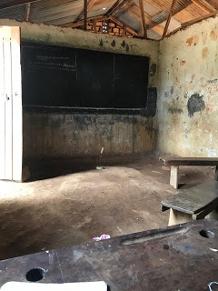

PROFESSIONAL ENGAGEMENT
Other engagements included meetings with the SOS President, Richard Pichler, who flew in from Austria to discuss the needs of Uganda. Continual educational guidance for the project is supported by SOS National Director Olive Birungi Lumonya, as we visited each school. https://youtu.be/uteVqpaQKvQ
The project was approved by the Minister of State for Higher Education, Hon. Dr. John Chrysostom Muyingo (MP) in a formal meeting with national directors for education and press coverage.
We look forward to uniting our school community with intense purpose and involving our students in philanthropy to initiate change. Here is a link to our video http://www.victoriavillage.com/philanthropy.html

